SOC ROLE in Blue Team Walkthrough
This is a Walkthrough of the SOC role in Blue Team in the Try Hack Me Platform.
Task 1: Introduction
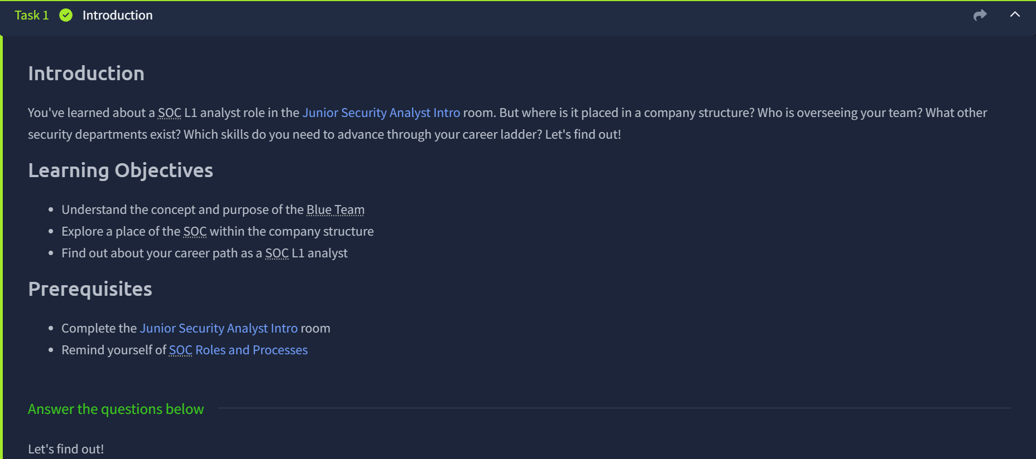
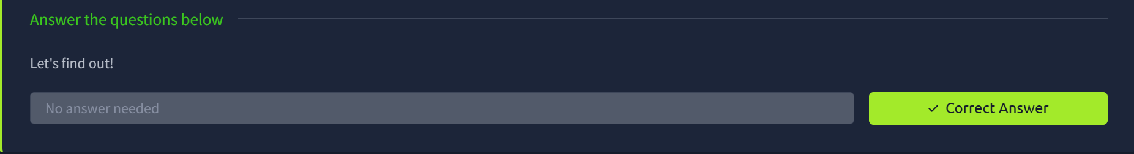
Task 2: Security Hierarchy
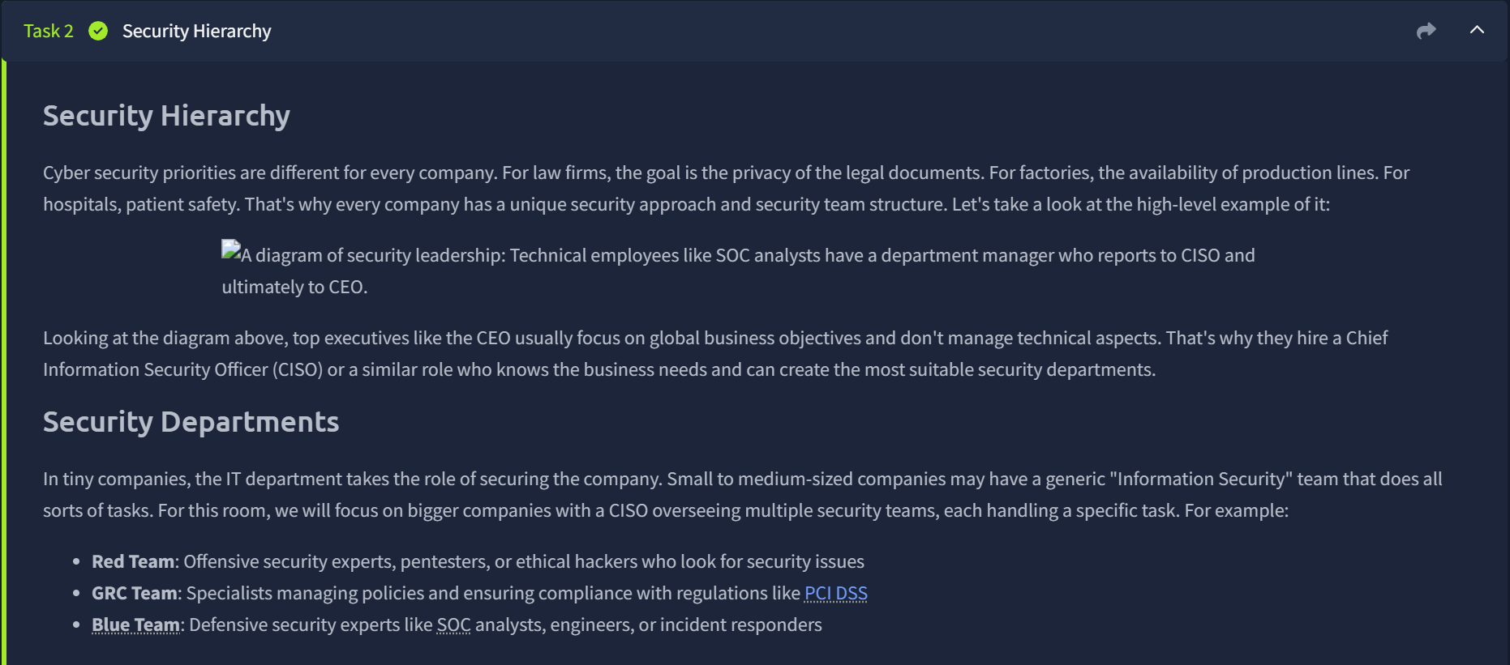
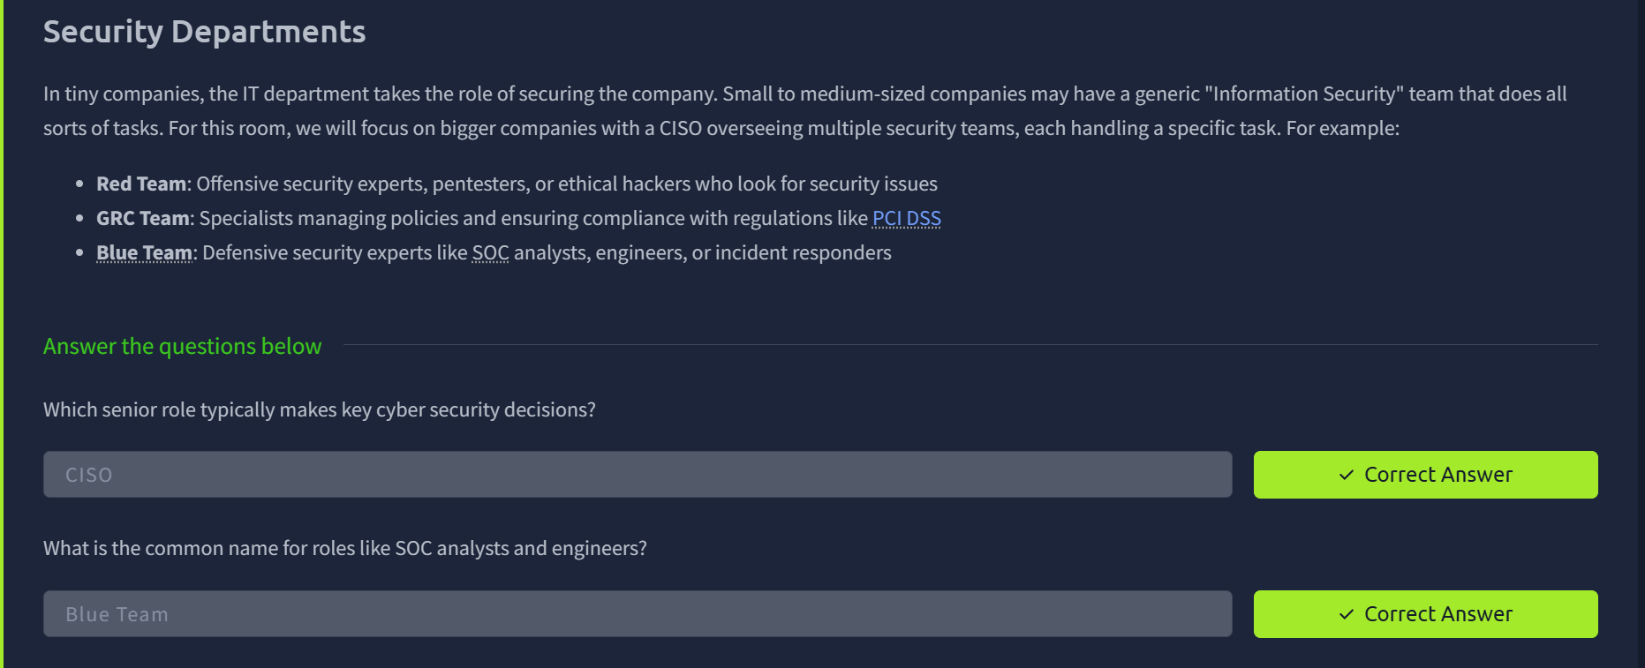
PCI DSS - The Payment Card Industry Data Security Standard (PCI DSS) is a global data security standard that regulates how entities store, process, and transmit cardholder data (CHD) and/or sensitive authentication data (SAD). PCI DSS includes guidelines regarding components of organizations' technical and operational system that are related to such data.
Task 2 Questions
Q: Which role typically makes key cyber security decisions?
CISO – The Chief Information Security Officer knows the business needs and creates suitable security departments.
Q: What is the common name for roles like SOC analysts and engineers?
Blue Team – This is the defensive security experts like SOC analysts, engineers or incident responders.

Task 3: Meet the Blue Team
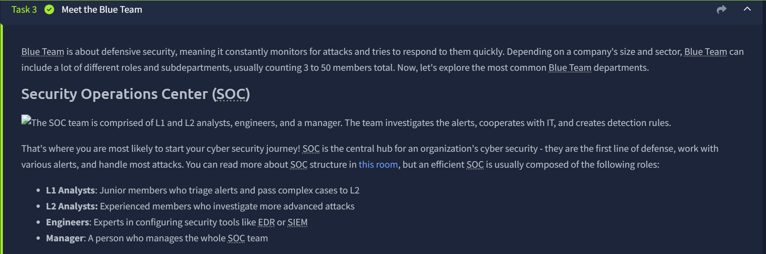
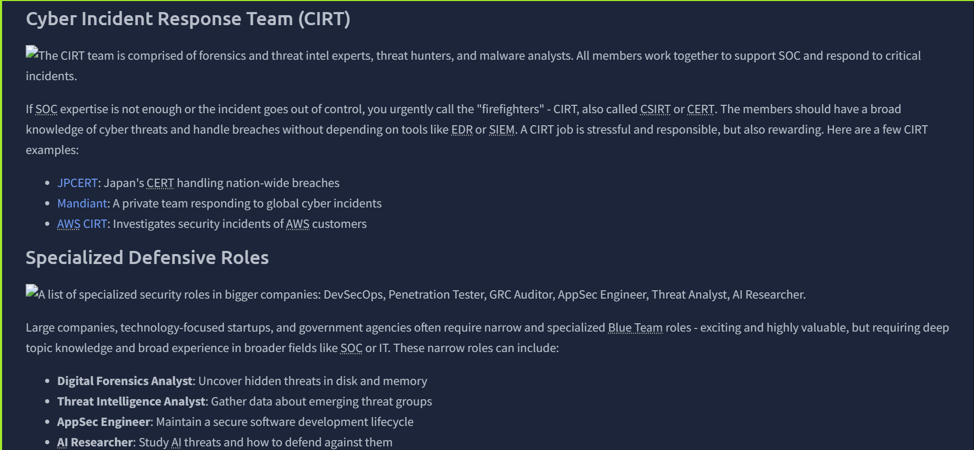
Task 3 Questions
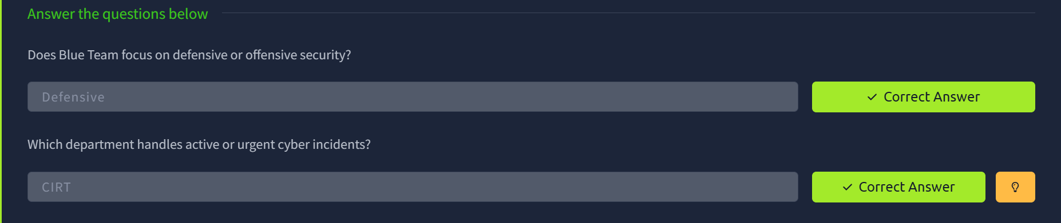
Q: Does Blue Team focus on Defensive or Offensive Security?
Defensive Security – The blue team focuses on defensive security, meaning it constantly monitors for attacks and tries to respond to them quickly.
The Red Team focuses on Offensive security, meaning it tries to simulate attacker techniques and methods to protect the security of a firm.
Q: Which department handles active or urgent cyber incidents?
CIRT – Cyber Incidents Response Team.
This team is responsible for managing and responding to cybersecurity incidents to minimize damage and ensure recovery.

Task 4: Advancing SOC Career
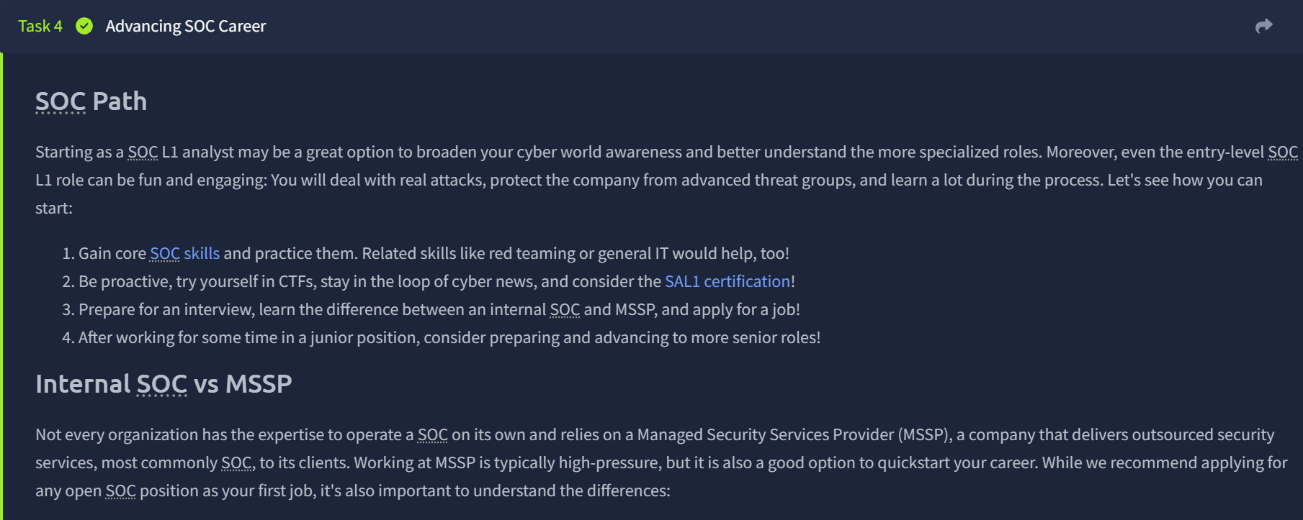
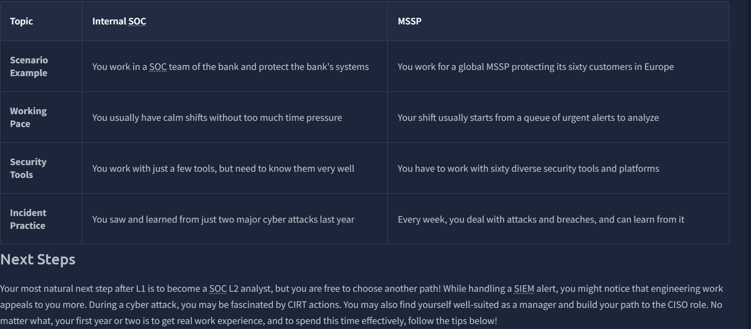
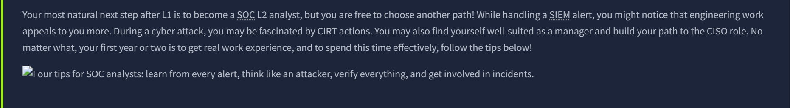
Task 4 Questions
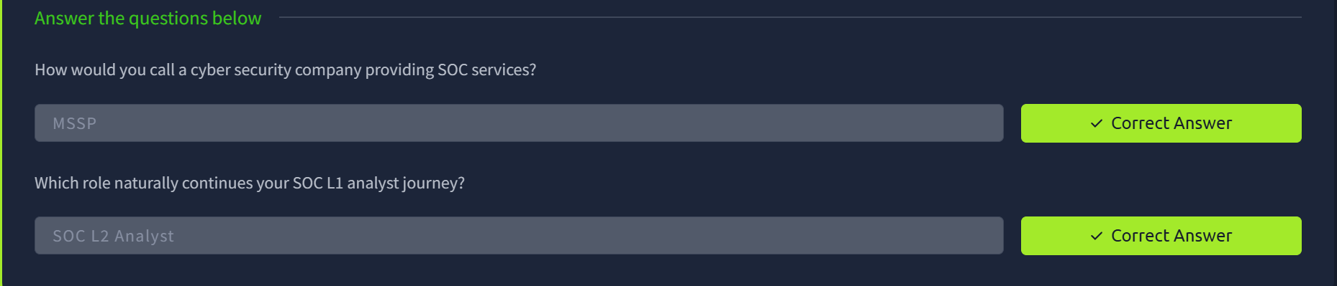
Q: How would you call a cyber security company providing SOC services?
MSSP – Managed Security Services Provider, a company that delivers outsourced security services, most commonly SOC, to its clients.
Q: Which role naturally continues your SOC L1 analyst journey?
Your most natural next step after L1 is to become a SOC L2 analyst, but you are free to choose another path!
Task 5: Final Challenge
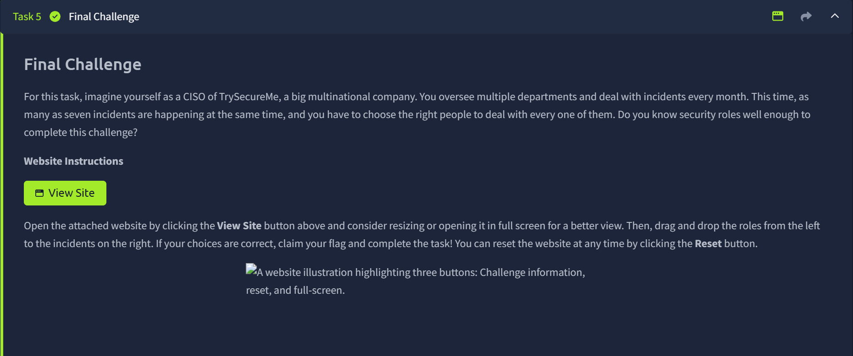
The “View Site” Page
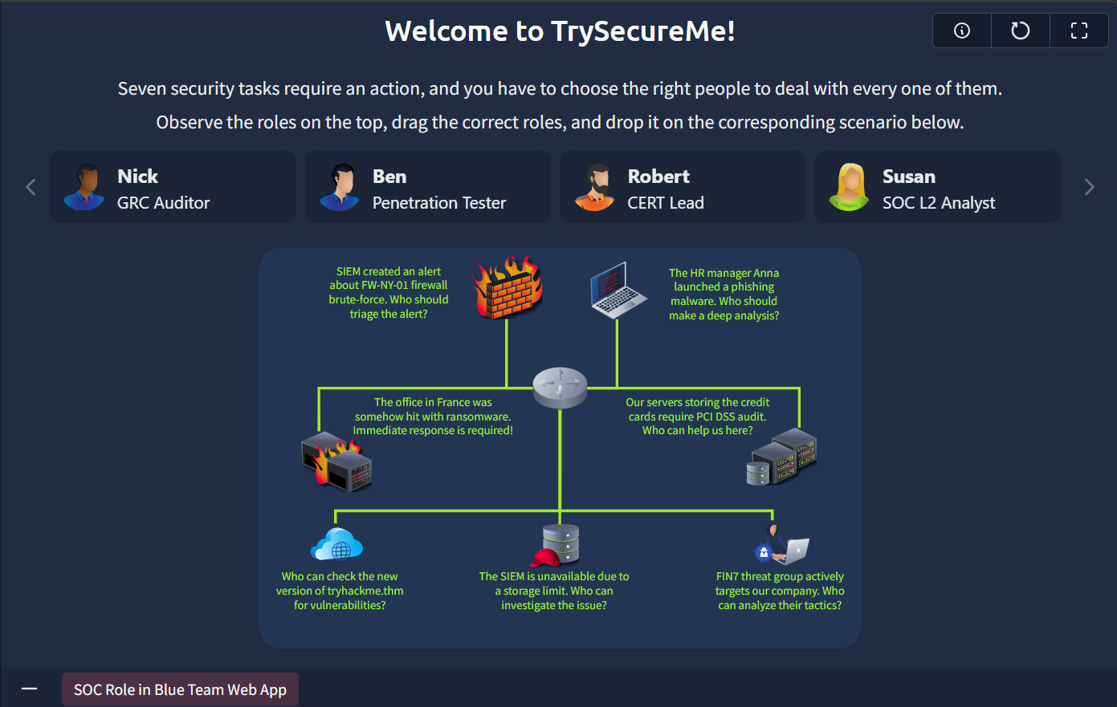
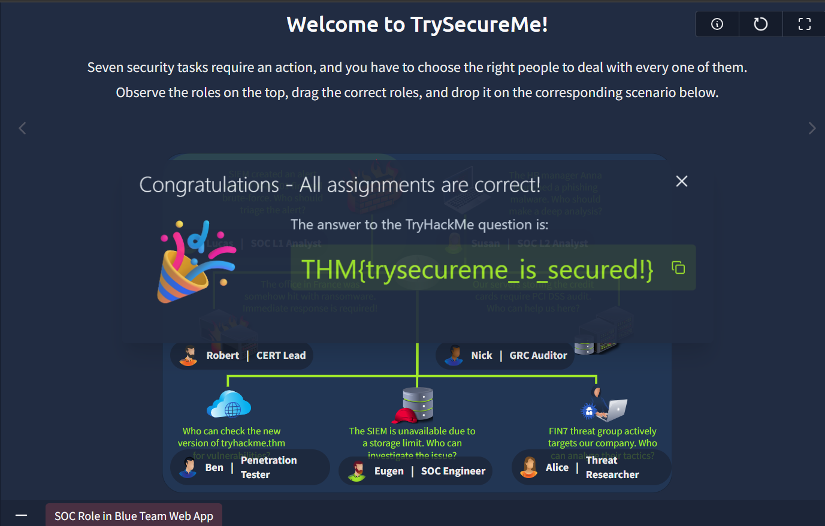
TrySecureMe Assignments
- SIEM created an alert about FW-NY-01 firewall brute-force. Who should triage the alert? – Lucas – SOC L1 Analyst.
- The HR manager launched a phishing malware. Who should make a deep analysis? – Susan – SOC L2 Analyst.
- The office in France was somehow hit with ransomware. Immediate response is required – Robert -CERT Lead.
- Who can check the new version of tryhackme.thm for vulnerabilities? Ben| Penetration Tester.
- Our servers storing the credit cards require PCI DSS audit. Who can help us here? Nick | GRC auditor.
- The SIEM is unavailable due to a storage limit. Who can investigate the issue? Eugen | SOC Engineer.
- FIN7 threat group actively targets our company. Who can analyze their tactics? Alice | Threat Researcher.
Task 5 Questions
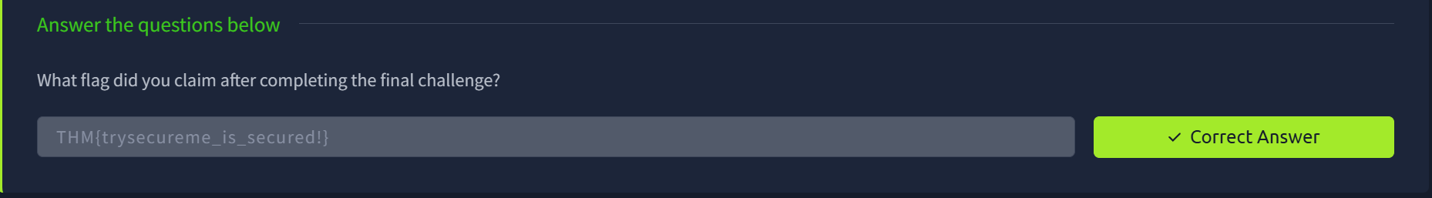
Flag: THM{trysecureme_is_secured!}

Task 6: Conclusion
